Week 8 - Seminar Questions

Question 1

Correlation tells you that:

1. one of your variables changing causes the other to change.

2. there's a third hidden variable causing both of your variables to change.

3. two variables are linked.

4. that something significant is going on.

Question 2

We graph data before regressing it because:

1. we need to see whether the data have a linear relationship.

2. graphs are pretty.

3. bar charts are the best way to see the data.

4. it shows the significance of the data.

Question 3

Which of the following is true about this SPSS output?

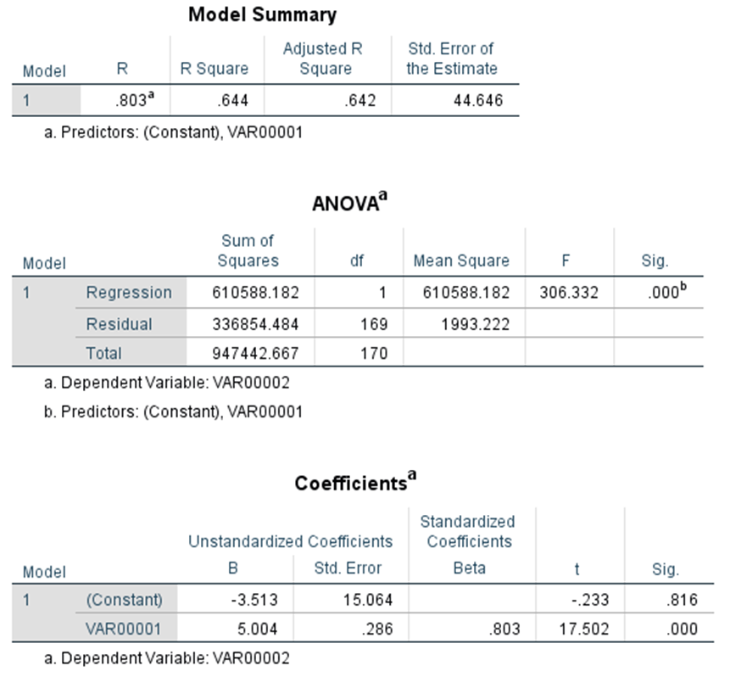

1. The regression equation is Var2 = 0.286 Var1 + 15.06

2. Because R=0.803, 80.3% of the variation of the data around the mean is explained by Var1.

3. There were 170 datapoints.

4. The slope is significantly different from 0, but the intercept is not.

Question 4

Given the three following points, what is the slope (B)?
x y
- 2.7 9.7
- 12.9 9.8
- 17.3 11.6

Question 5

Given the three following points, what is the predicted y value for an x value of 7.3?
x y
- 6.4 2
- 5 6.1
- 17.3 16.2

Question 6

"Interpolation" of data is predictive, and caution must be used

True
False

